Project Synopsis – News Portal

# 1. Project Title:

News Portal

# 2. Objective:

To develop a responsive, dynamic, and user-friendly web application where users can post, edit, delete, read, search, and categorize news articles in real-time and admin can approve and delete the posted news.

# 3. Scope:

* - User can manage news content (add/edit/delete).
* - Users can view news by category (Politics, Technology, Sports, etc.).
* -Admin can review the news posted by users and will approve or disapprove it.
* - Responsive design for mobile and desktop.
* - Option for search, filter, and latest news highlights.

# 4. Modules:

* User Module:
* - View categorized news
* - Search functionality
* - Create, update, delete news articles
* - Manage categories and images
* Admin Module:
* - Login authentication
* - Manage Posted News (Approve / Delete)

# 5. Tools & Technologies:

* - Frontend: React, CSS, Bootstrap
* - Backend: Node JS, Express JS
* - Database: MongoDB
* - Tools: Visual Studio Code

# 6. Day-wise Development Plan:

1. **General Zone**

**Day 1&2 (Designing of General Zone’s Home Page):**

* **Menus and Slider**

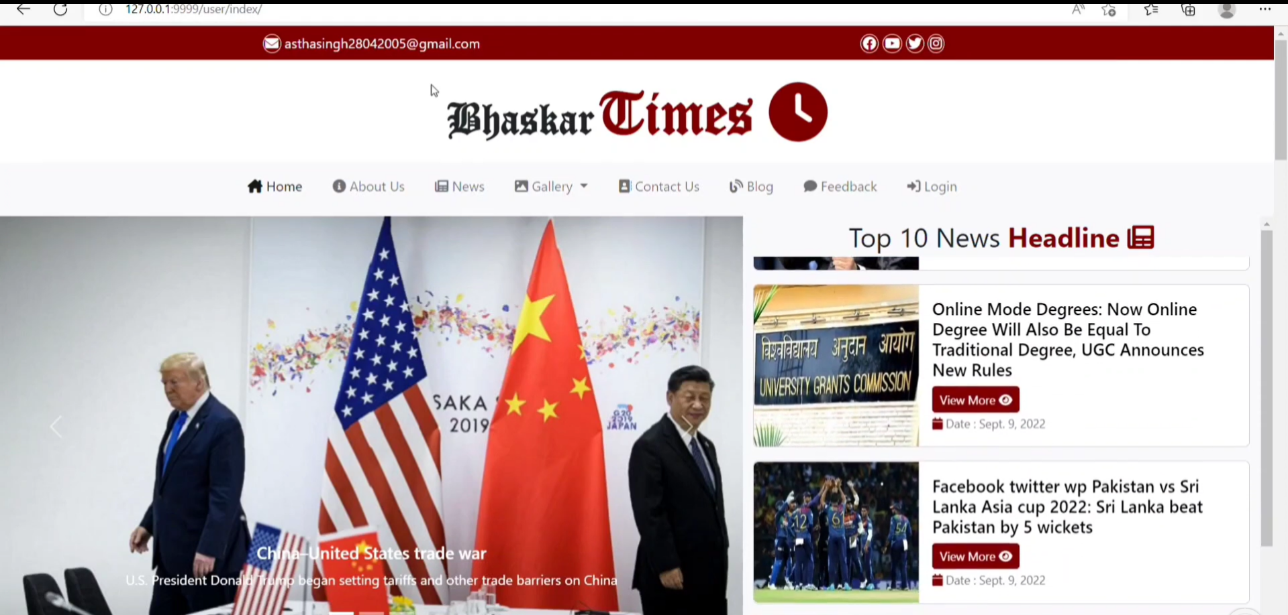

* **News Category**

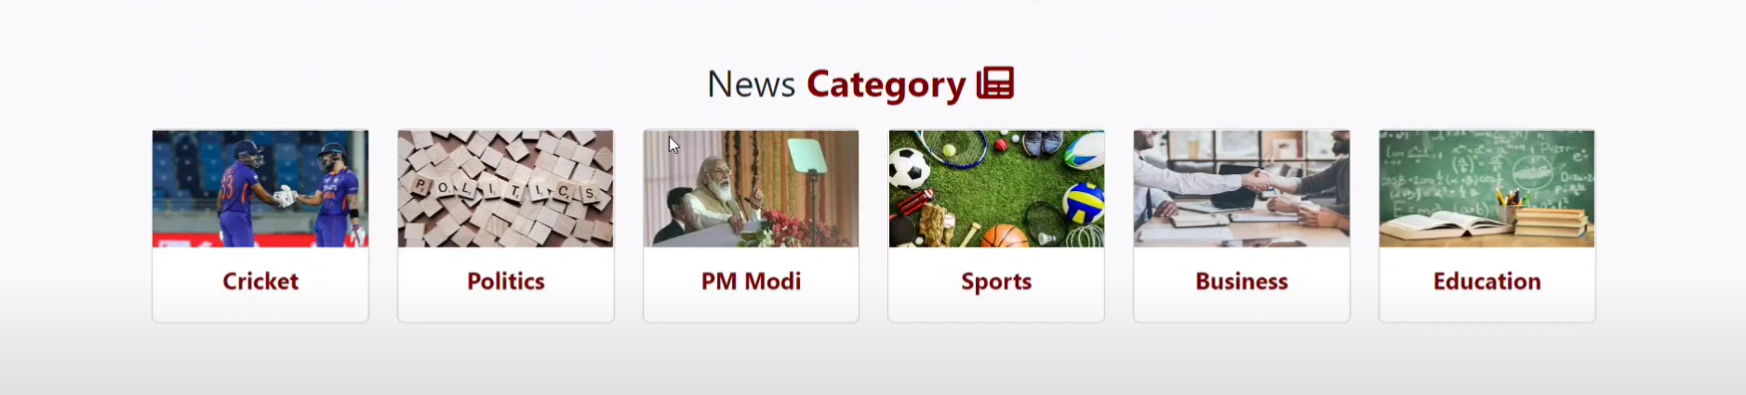

* **News Details**

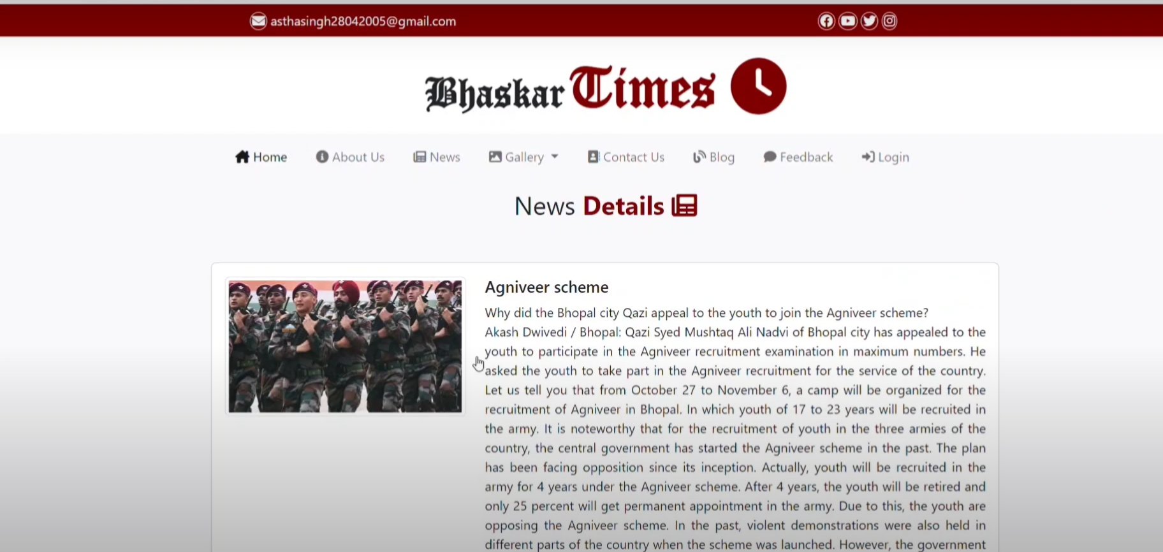

* **Latest News**

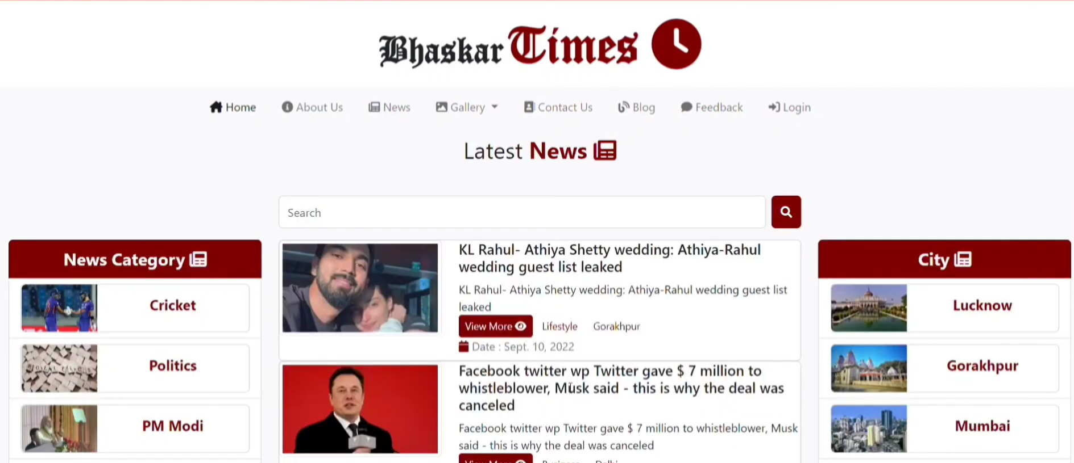

* **Latest Videos**

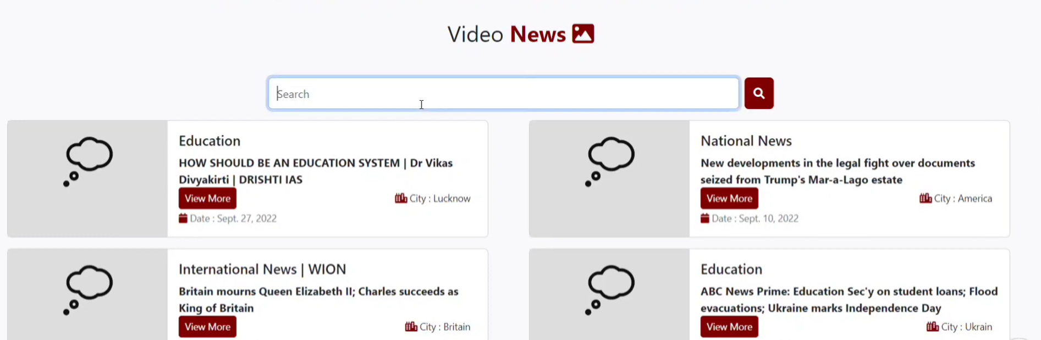

* **Cities**

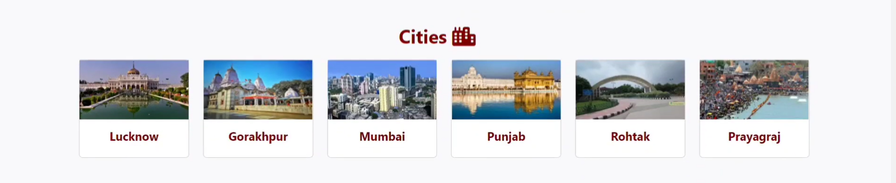

* **Image Gallery**

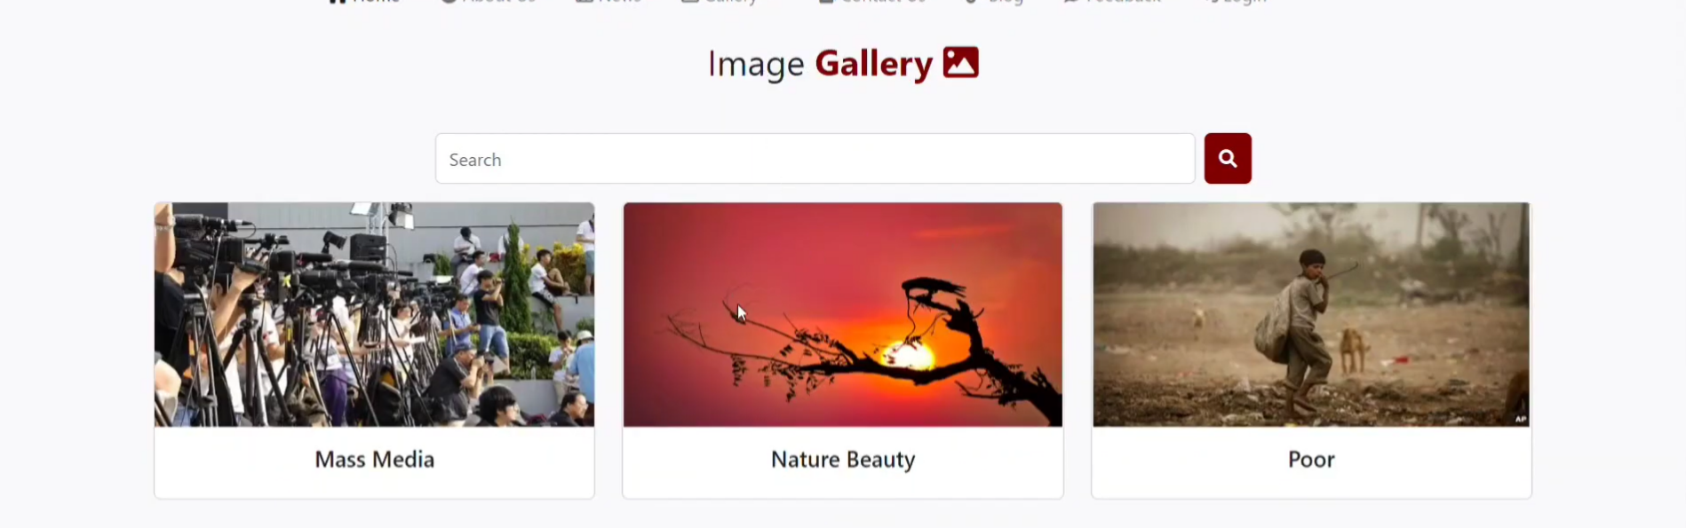

* **Contact Us**

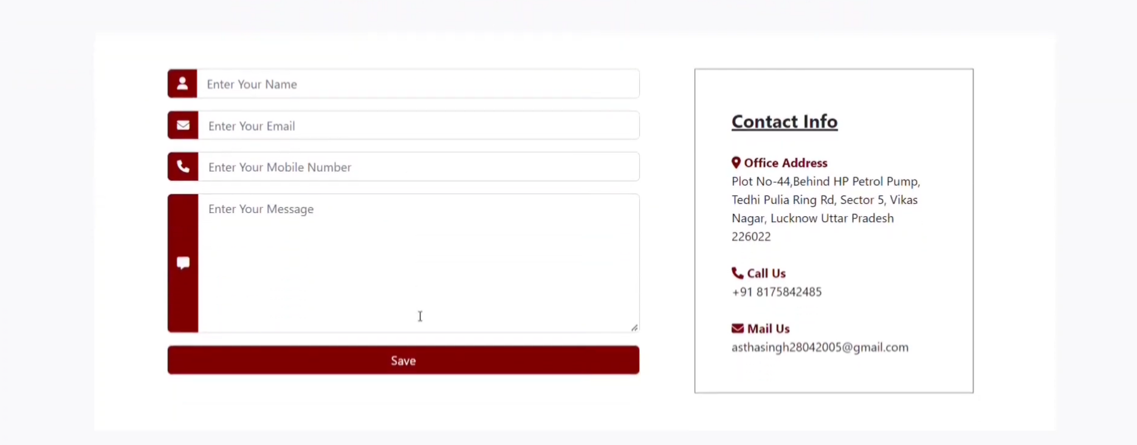

* **About Us**

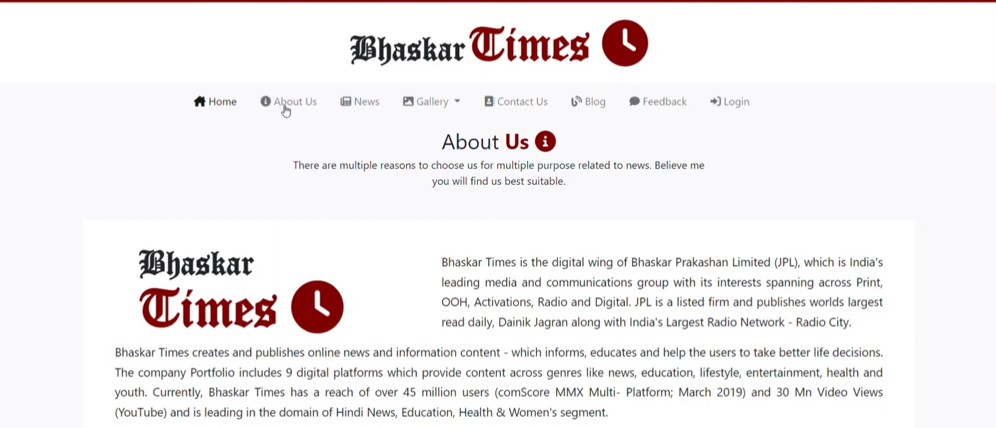

* **Feedback**

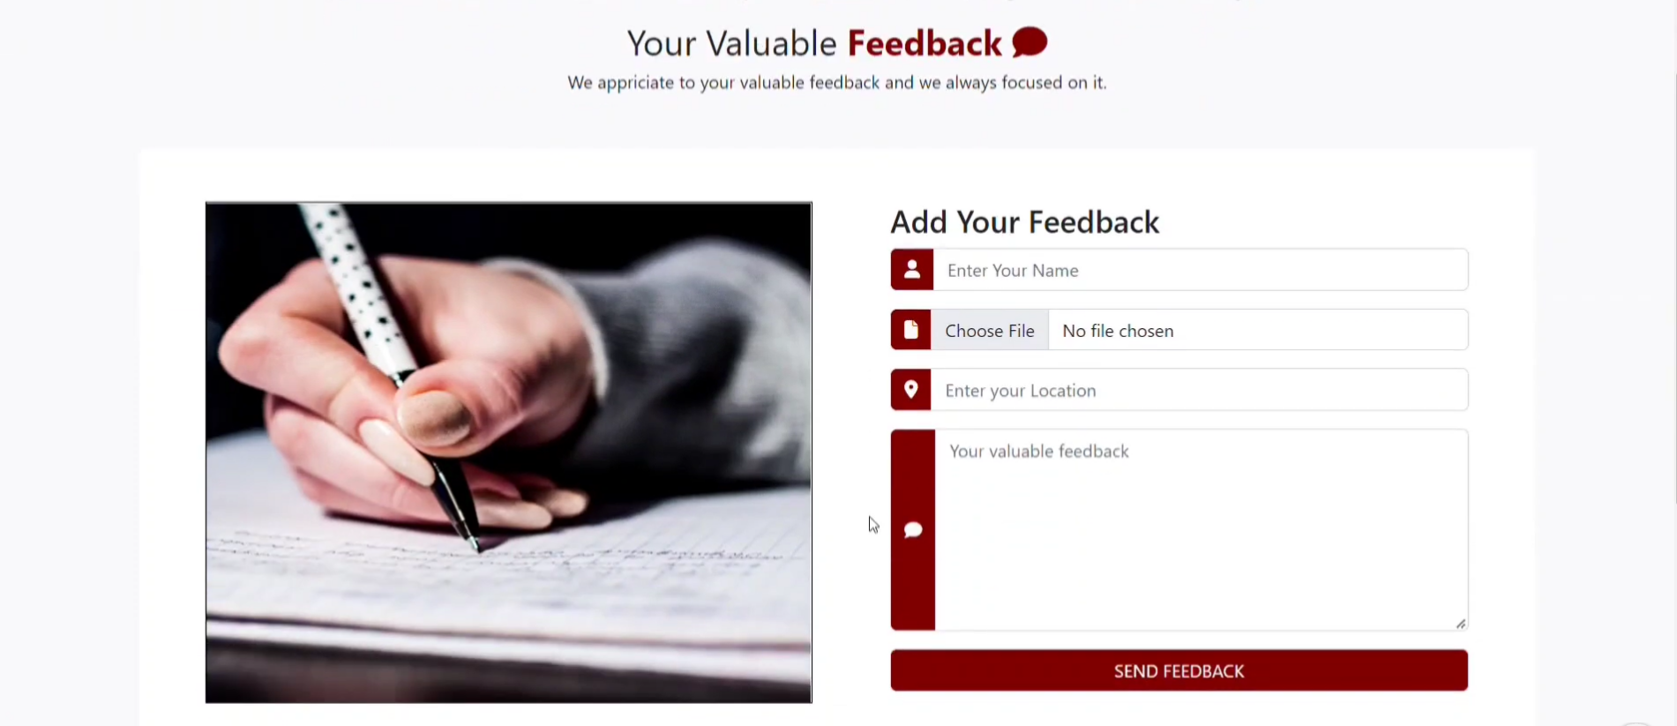

* **Footer**

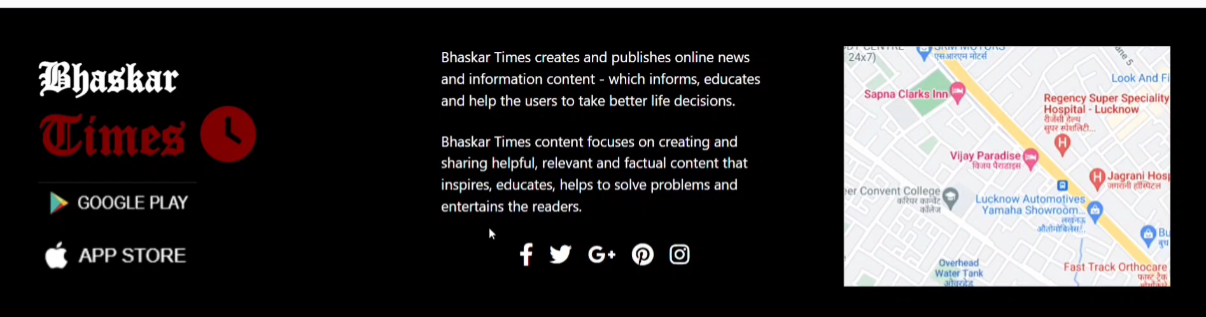

1. **Admin Zone**

**Day 3 (Designing and Coding of Admin Registration & Login):**

* **Admin Registration**

Admin Registration through Postman API.

* **Admin Login**

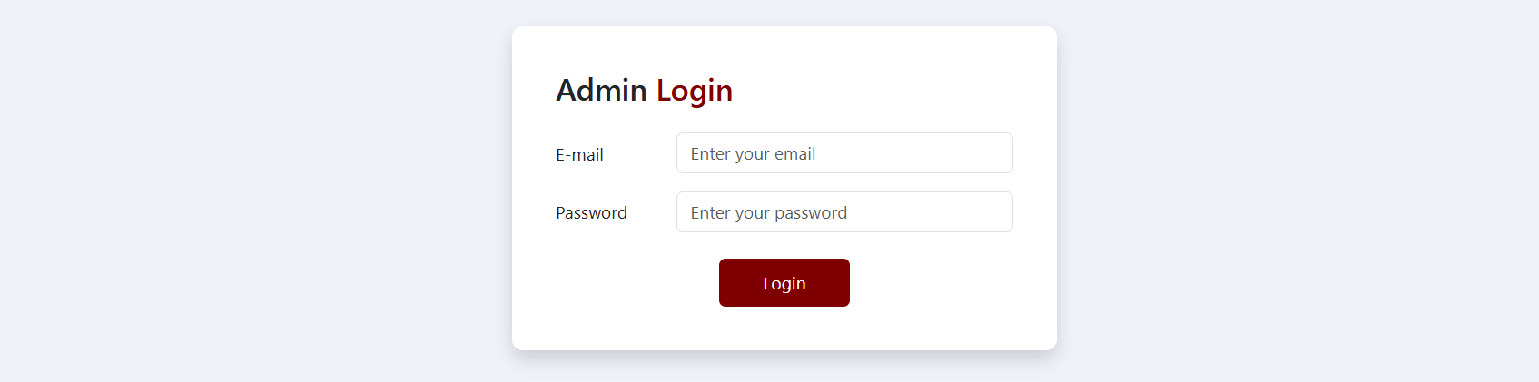

**Day 4 (Designing and Coding of Admin Edit Profile & Posted news table & Logout):**

* **Admin Edit Profile**

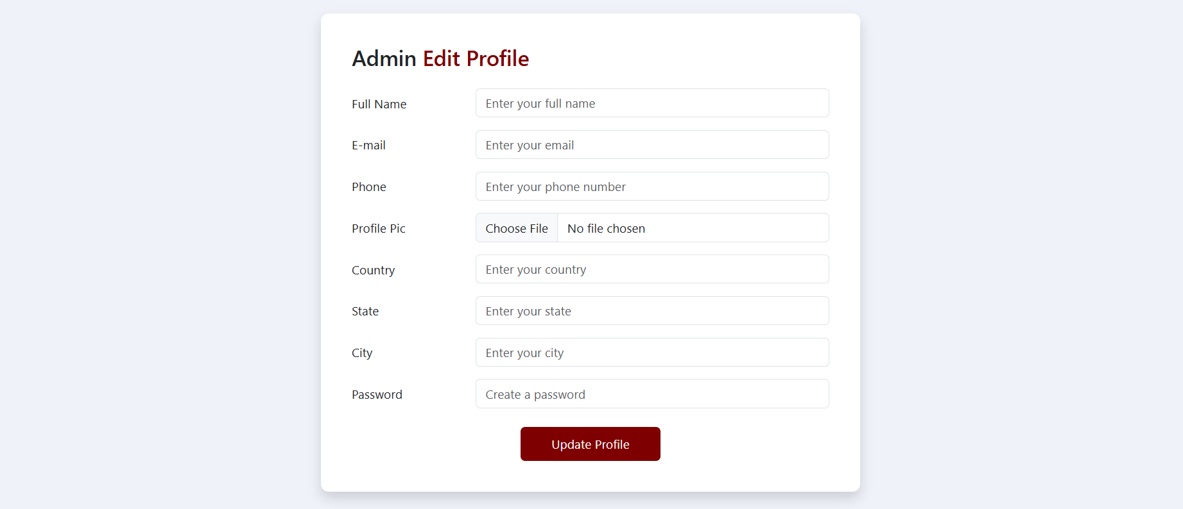

* **Posted News Table**

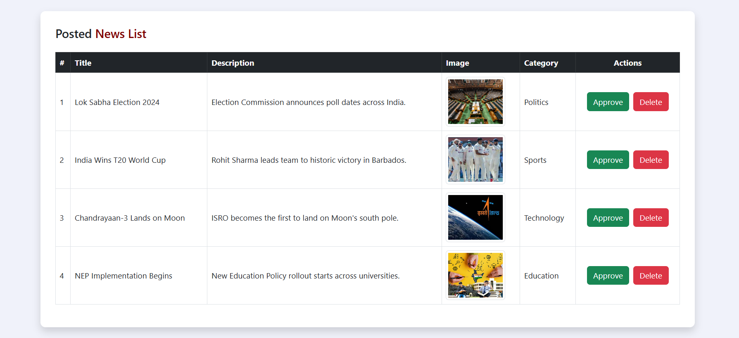

* **Logout**

Logout page will destroy the created session at the time of login in Admin Zone and redirect at login page.

1. **User Zone**

**Day 5 (Designing and Coding of Registration & Login):**

* **User Registration**

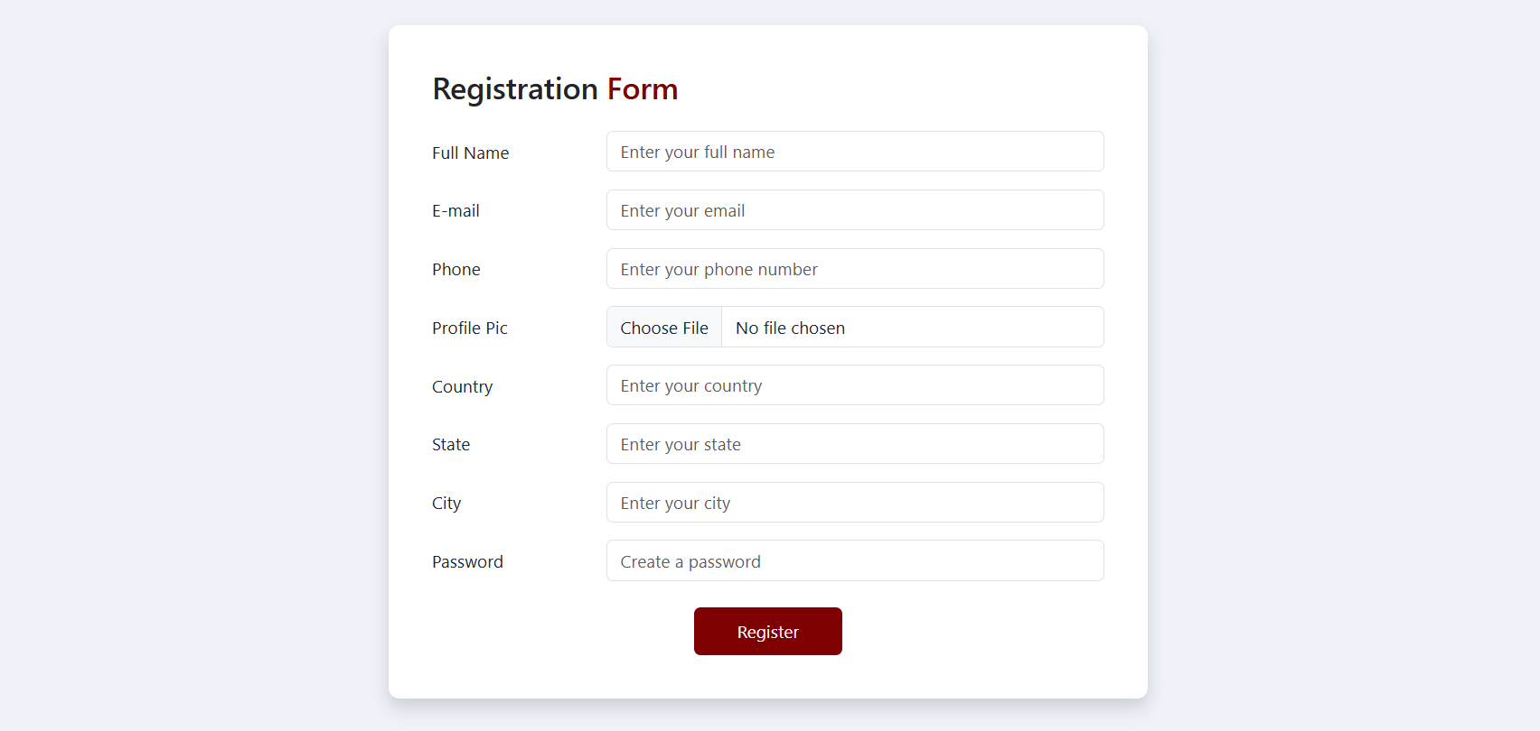

* **User Login**

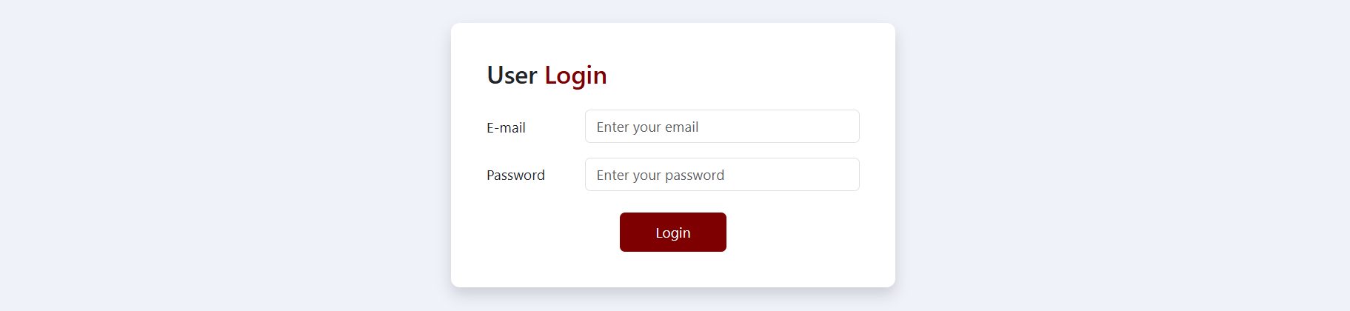

**Day 6 (Designing and Coding of Post News):**

* **Post News**

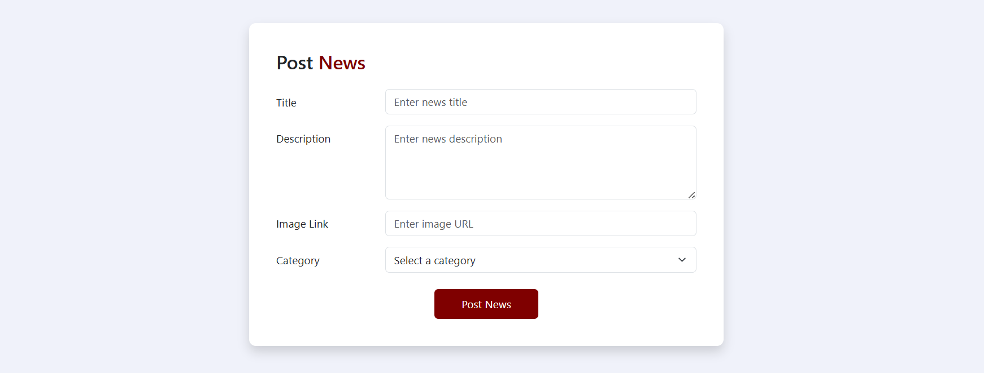

**Day 7 (Designing and Coding of All News & Your News):**

* **All News**

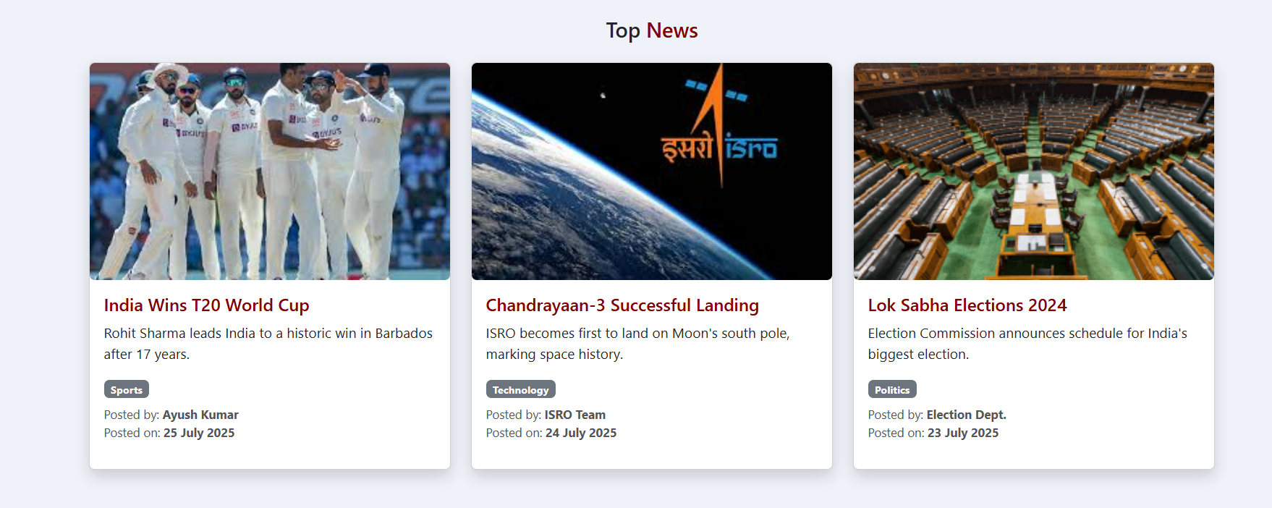

* **Your News**

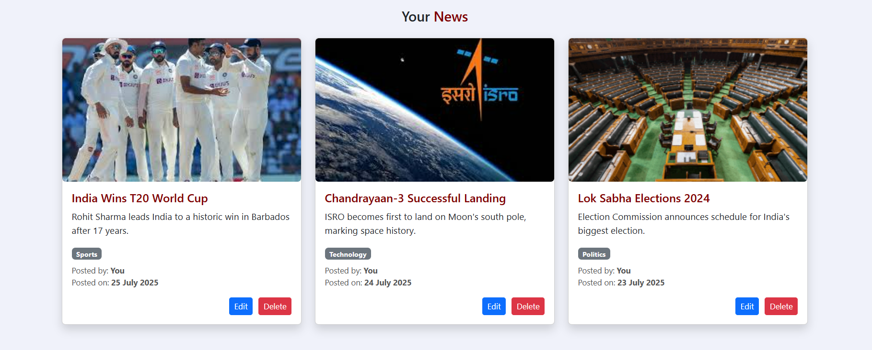

**Day 8 (Designing and Coding of Edit News and Delete News):**

* **Edit News**

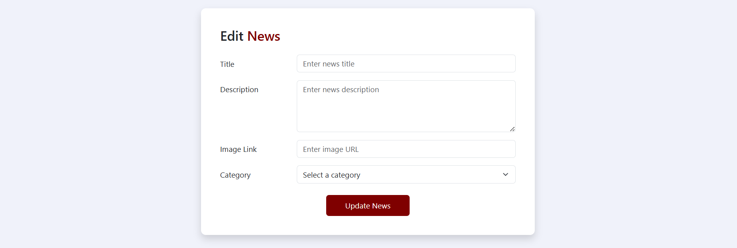

* **Delete News**

Delete News page will Delete the currently selected news.

**Day 9 (Designing and Coding of Edit Profile & Logout):**

* **Edit Profile**

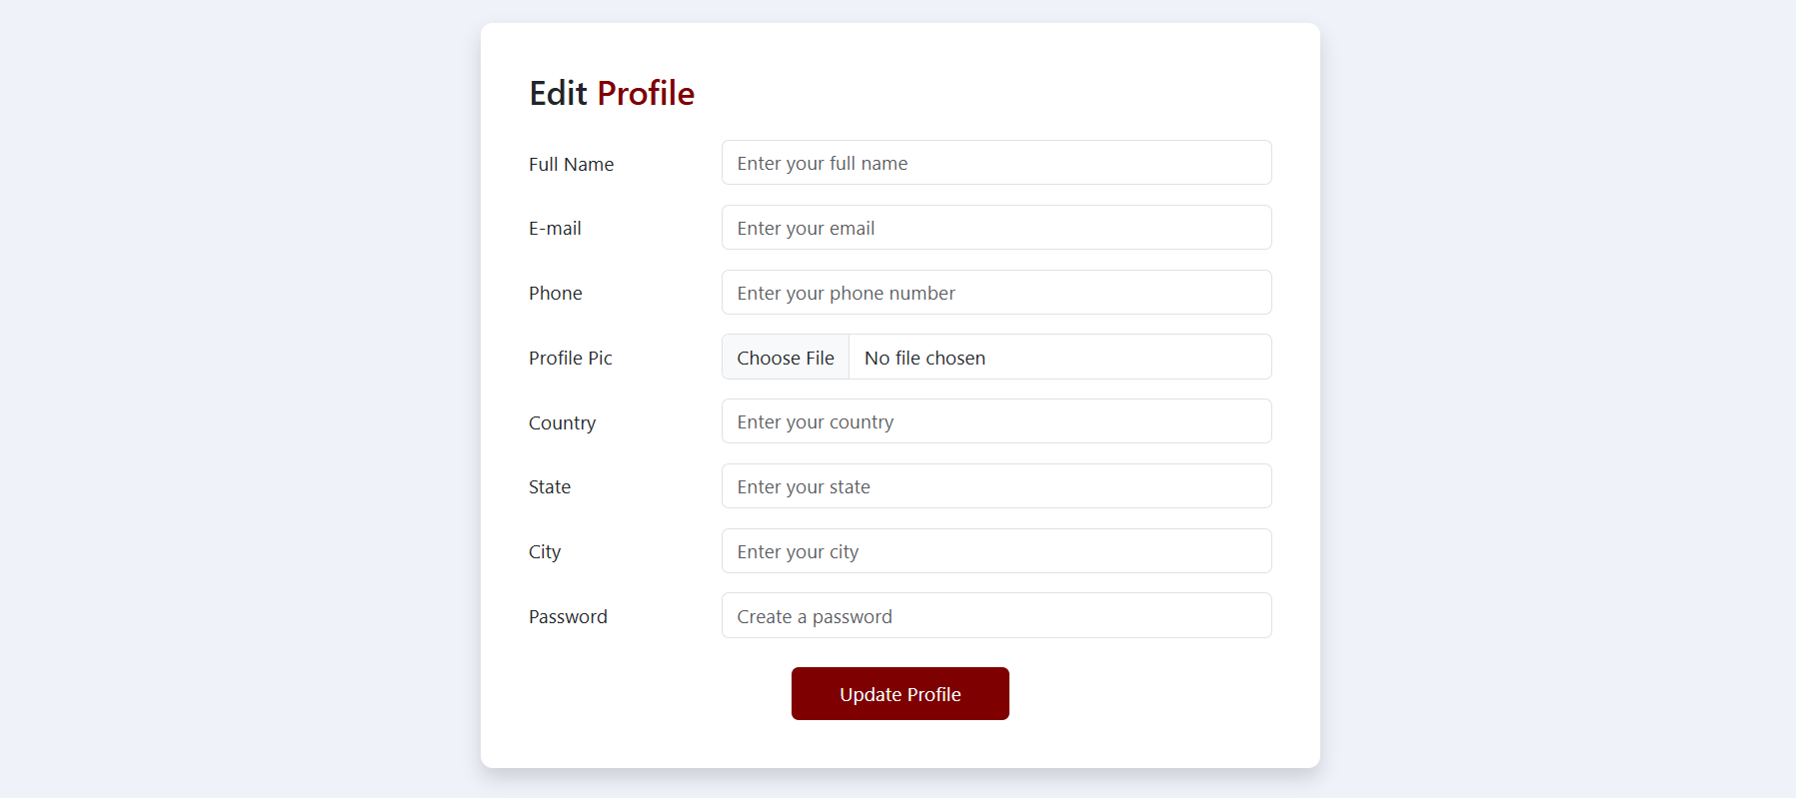

* **Logout**

Logout page will destroy the created session at the time of login in Admin Zone and redirect at login page.

**Folder Structure**

